Game of Life
Name | Game of Life
Description | Game of Life cluster
Status | Running
Contact | orimpe
Participants: | metalgamer
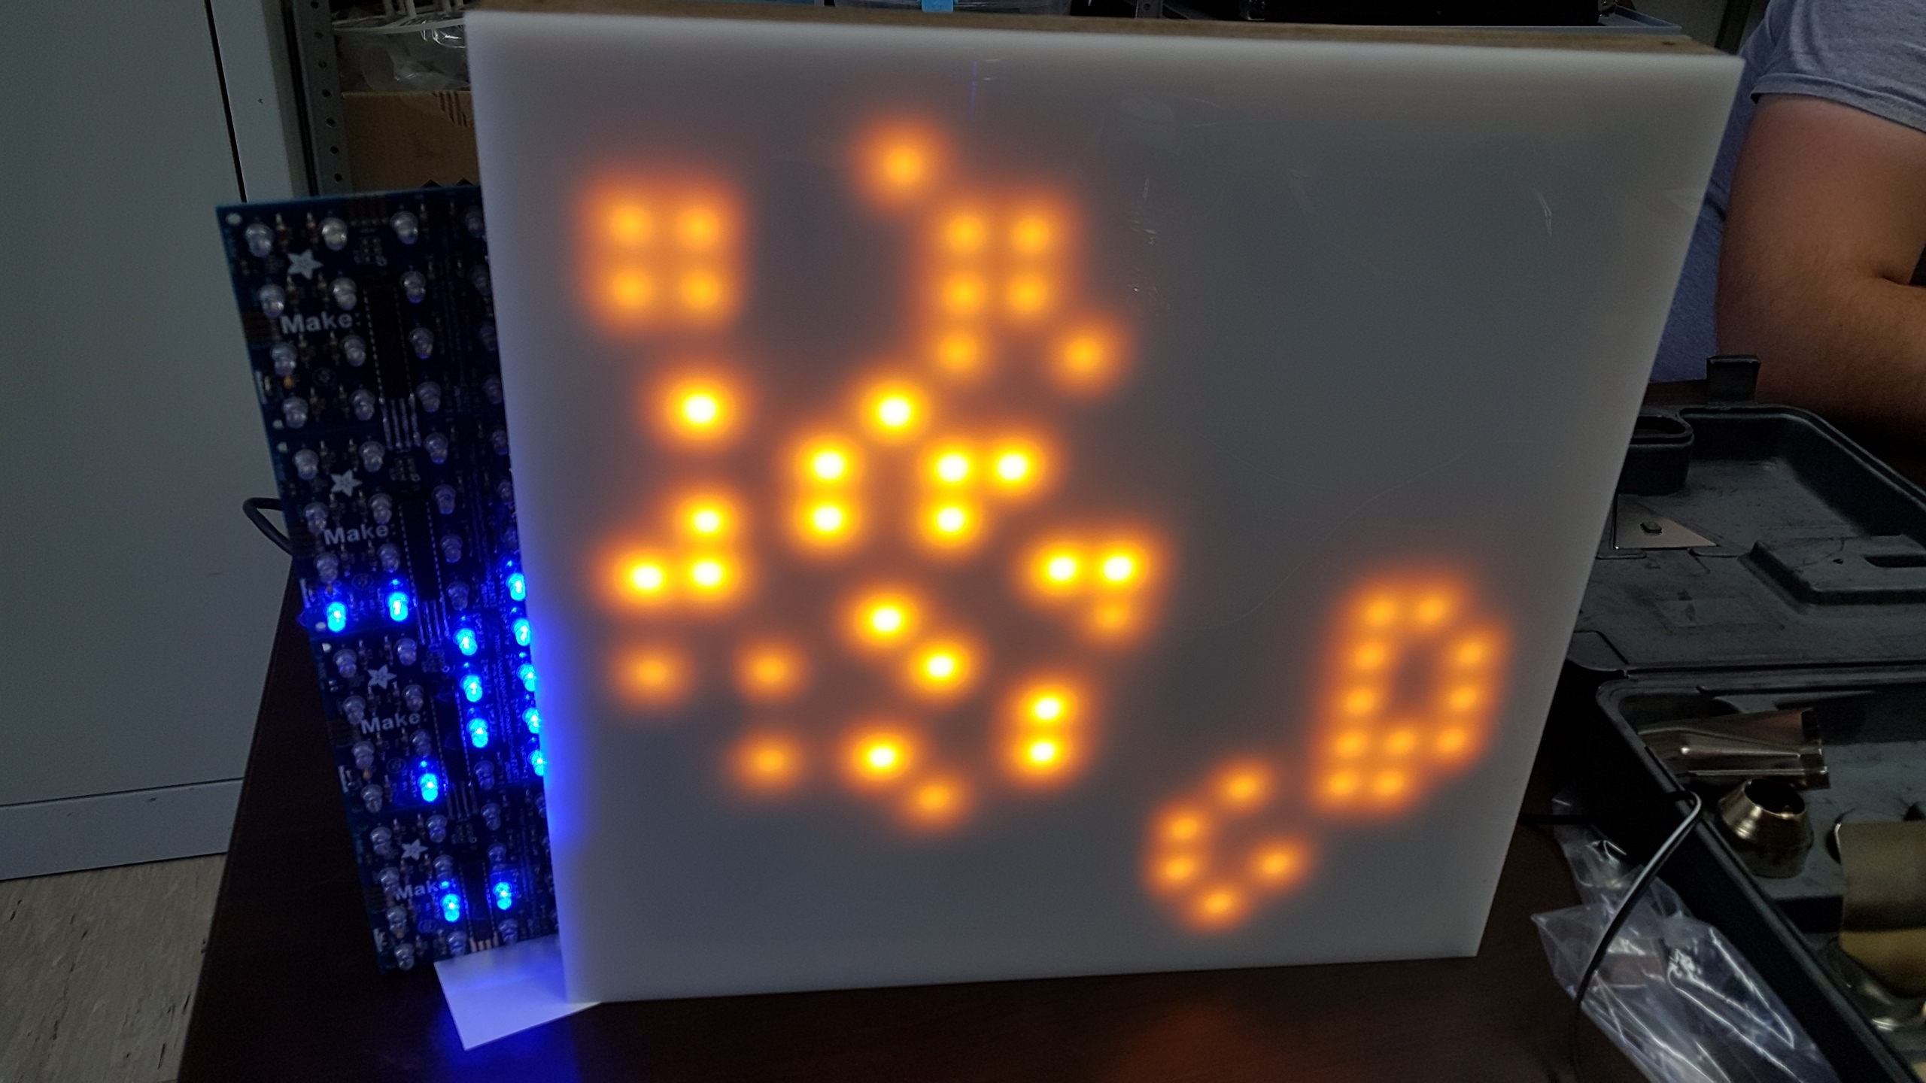
We use 16 Adafruit Game of Life's and High Power LED's and connect each other Panel, so we get a huge Game of Life with different colors. It's not the perfect because its really expensive by using the soldering kits …
Here on the right is a finish panel (with orange LED's) an the first pieces of the second panel (with blue LED's) →

Partlist
- Adafruit Game of Life
- 8PIN DIN connector
- LED 5mm klar orange 2500mcd
- 25mm x 25mm Wood
- 335mm x 335mm x 5mm Acrylglas

How is the wiring


